A000-Indo-Papua New Guinea-Necklace- Moka Kina Shell- Foi tribe-woven clasp-19th c

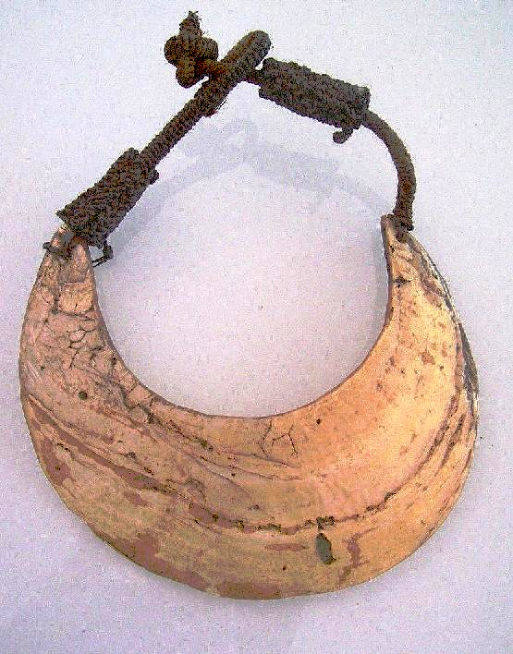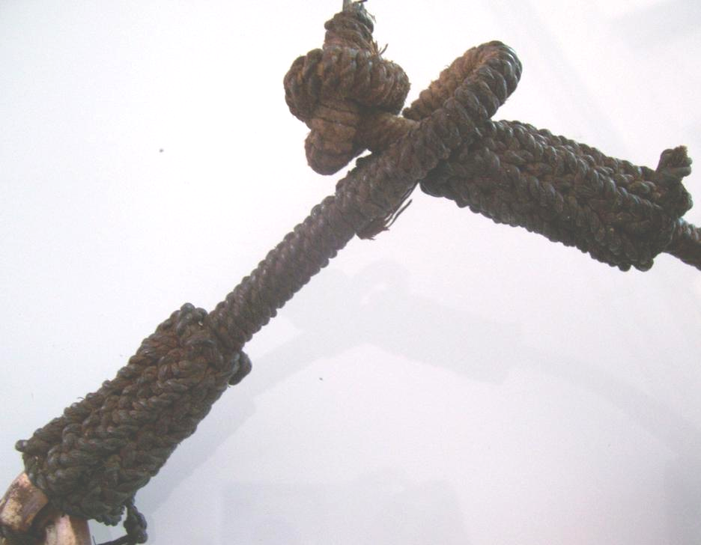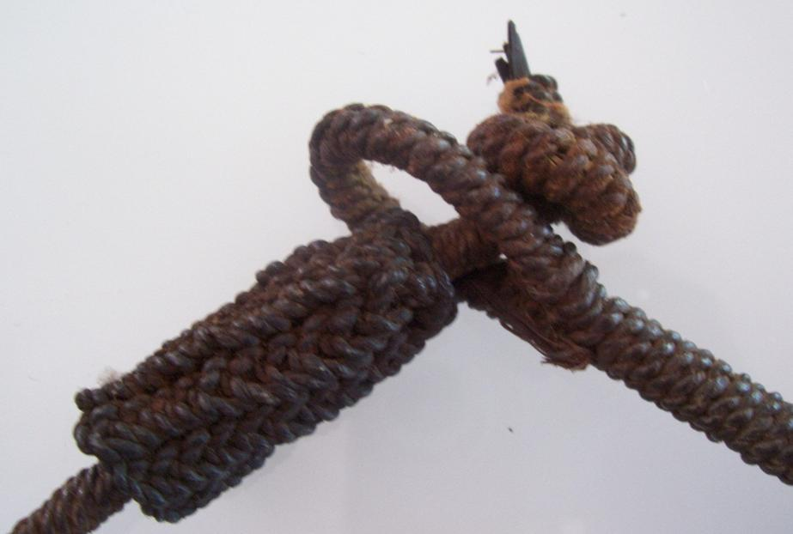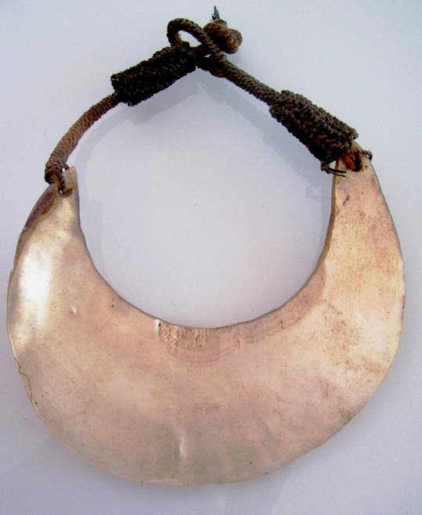

Figs. 1-4. Indo-Papua New Guinea-Necklace- Moka Kina Shell- Foi tribe-woven clasp-19th c

Case No.: 13

**Accession No.**

**Formal Label:**

**Display Description:**

Kina shell gorgets are so-called because of their crescent shape. They can be made of abalone shells or any large mollusk that had a large enough area to be made into a crescent. This is a late 19th century or early 20th century example of an abalone shell that was used as currency in the Kula trade that was studied by Bronislaw Kaspar Malinowski who did field research on the islands between 1916 and 1920 and published his results as *Argonauts of the western Pacific* in 1922 (see Young, 2004; also Senft, 1999). Originally, this abalone shell was obtained by Sepik River canoeists from Melville or Bathurst Islands north of Australia, some 1000 miles away. Then it was made into a kina gorget and was finally obtained by a woman in Magendo Village on the Sepik River, Papua New Guinea through the Kula trade network. When kina shells are used as currency they may be mounted onto an oval clay-covered display board called a *moka*and stained with bright red dyes. The more golden the color, the more valued the piece. Today Sepik River men still procure abalone shells from Bathurst and Melville Islands.

Very large and important unique older collectable Pectoral Adornment, as seen in museums: Huge mother of pearl very scarce tribal shell ornament carved in a ½ moon shape from a gigantic shell called the Kina Gold lip shell (Pinctada maximums), collected in the field in a remote region of PNG, Papua New Guinea. Collected in the field in the highlands of Papua New Guinea, Mount-Hagen area. (19th Century). Shell has uneven edges in places as expected from a shell,

When a kina is used as payment in a ceremony, it is often stained with bright red dyes as here: the front side is reddish colored. When the rear side of one of those pieces bears markings of clay and resin, it means that it was once presented on a tray and attached with resin. It is even more valuable as a currency then and demands further respect.

Necklaces, headbands and armbands are knotted from handmade string and may include seeds, trade beads, feathers and fur, grasses and ferns, croton leaves, yellow orchid vine, everlasting daisies, links of bamboo and fiber chains.

At feasts or bride negotiations, together with other bride presents, a corresponding number of Kina Shells were presented on a tray.

Particular large and beautiful Kina Shells were often given their own name and kept in richly decorated bags. They were offered as gifts during ceremonies and feasts.

The Kina Shell is part of the shell of the Gold lip shell (Pinctada maximums) and was part of the traditional payment and medium of exchange in Papua New Guinea and Irian Jaya. It is at the origin of the name given to the modern currency: "Kina", in Papua New Guinea.

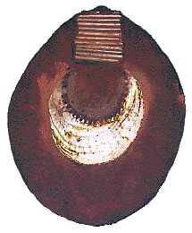

Kina shell used as currency. From http://www.art-pacific.com/images/kinaf.gif

**LC Classification:** N7411.S4.

Date or Time Horizon: late 19th century or early 20th century

Geographical Area: Papua New Guinea-Middle Sepik River-Magendo Village

**Map, GPS coordinates: -4.09252 144.03349;** 40° 26' 46" N 79° 58' 56" W.

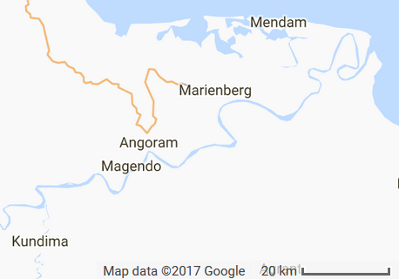 

Figs. Magendo village detailed map and within Melanesia. From http://latitude.to/lat/-6.28066/lng/-163.40791.

Cultural Affiliation:

Media: Bush twine, abalone shell.

Dimensions:

Weight:

Condition: original

Provenance: Magendo village

**Discussion:**

Archaeological evidence indicates that the humans who first arrived in Papua New Guinea around 45,000 to 42,000 years ago were descendants of African migrants out of Africa. When agriculture was developed in the New Guinea highlands independently around 7000 BCE it was one of the few areas in the world where people independently domesticated plants. Then another major migration took place around 500 BCE by Austronesian-speaking peoples who settled coastal regions and introduced Lapita type pottery, pigs, and deep sea fishing techniques.

Headhunting was practiced in many parts of Papua New Guinea as part of rituals related to warfare. In 1901, on Goaribari Island in the Gulf of Papua, missionary Harry Dauncey found 10,000 skulls in the island’s Long Houses, a demonstration of past practices. Cannibalism was also practiced until quite recently. It involved the ingestion of flesh in which spirits or powers inhered. So that by ingesting the flesh of those deemed powerful, very gifted or great warriors or athletes one could become as powerful as that individual. Michael Rockefeller became the object of cannibalism when he demonstrated cool logic and great perseverance in arriving at an island south of Papua New Guinea during a major storm while clinging to two empty gasoline cans he had strapped himself onto (Machlin 2000). According to writer Marianna Torgovnick (1997), “The most fully documented instances of cannibalism as a social institution come from New Guinea, where head-hunting and ritual cannibalism survived, in certain isolated areas, into the Fifties, Sixties, and Seventies, and still leave traces within certain social groups.”

Although the middle Sepik River people have a common ancestry, each village is independent and this is reflected in their art, including their kina shells and masks. Every village carves in a distinctive style.

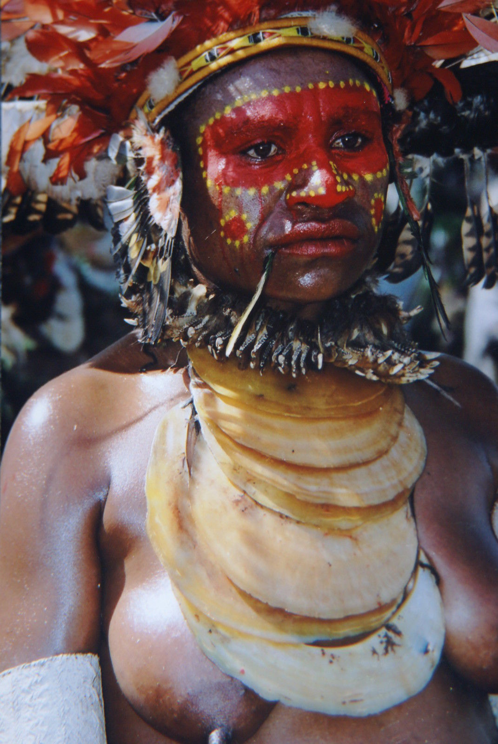

These shells are still used in traditional ceremonial payments and currency to this day throughout Papua New Guinea. After https://i.ebayimg.com/images/g/8-8AAOxyjzNRF135/s-l1600.jpgTraded from the coast into the highlands, Kina shells are used for bride price, blood feud paybacks, wealth displays and exchange festivals.

**References:**

Machlin. Milt. 2000. *The search for Michael Rockefeller*. Pleasantville, NY: Akadine Press.

Malinowski, B., 1922. *Argonauts of the western Pacific: an account of native enterprise and adventure in the archipelagoes of Melanesian New Guinea with a preface by Sir James George Frazer.* Studies in economics and political science; no.65. London: Routledge and K. Paul, Ltd; New York: E.P. Dutton and Co.

Senft, G. 1999. “Bronislaw Kasper Malinowski.” In: Verschueren, J., Östman, J.-O., Blommaert, J. (Eds.), *Handbook of Pragmatics. Supplement 1998*. Amsterdam: John Benjamins, pp. 1–10.

Torgovnick, Marianna. 1997. *Gone primitive: savage intellects, modern lives*. Chicago: University of Chicago Press

Young, M. 2004. *Malinowski: Odyssey of an Anthropologist 1884–1920.* New Haven and London: Yale University Press.